Class:

Tablet

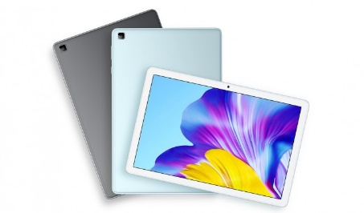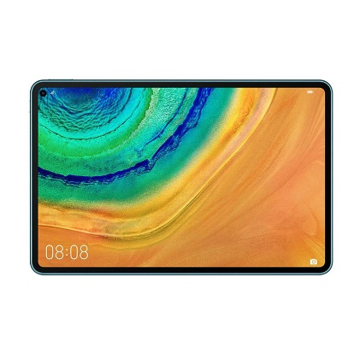

Brand: Huawei

Model: Huawei MatePad Pro

GPU: 16-Core Mali-G76 600 MHz

Brand: Samsung

Model: Samsung Galaxy Tab S7

GPU: Adreno 650

Brand: Honor

Model: Honor Tablet 6

GPU: Mali-G51 MP4

Properties:

Brand

Model

GPU

Behaviours:

Call()

Youtube()

Notification()

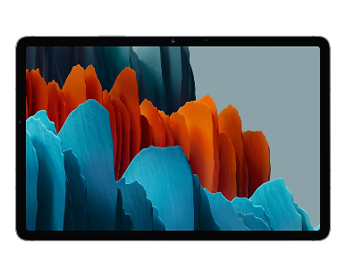

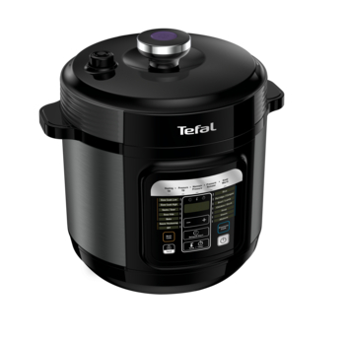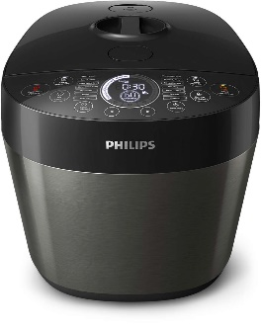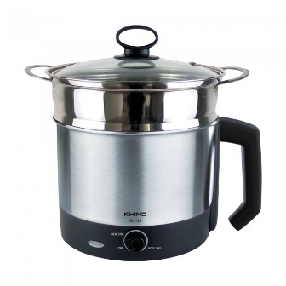

Class:

Multicooker

Properties:

Brand

Model

Bowl Capacity

Behaviours:

Simmer()

Boil()

Steam()

Brand: Khind

Power: 600W

Bowl Capacity: 1.6L

Brand: Philips

Power: 1000W

Bowl Capacity: 6.0L

Brand: Tefal

Power: 1000W

Bowl Capacity: 6.0L

Class:

Smart Watch

Properties:

Brand

Model

Released year

Behaviours:

Notification()

Call()

Time()

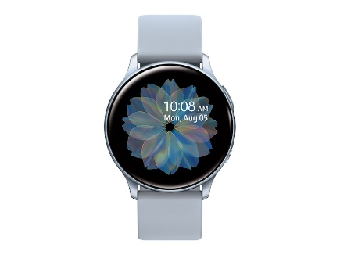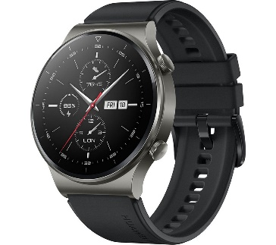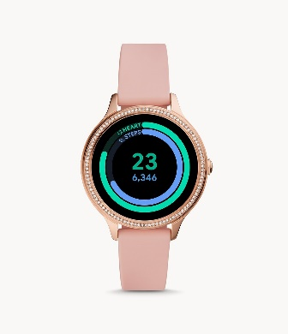

Brand: Huawei

Model: Huawei watch G2 Pro

Released year: 2020

Brand: Fossil

# Model: Gen 5E Smartwatch Blush Silicone

Released year: 2020

Brand: Samsung

Model: Samsung Galaxy Watch Active2

Released year: 2019

Class:

Breakfast Maker

Properties:

Brand

Voltage

Oven capacity

Behaviours:

Bake()

Toast()

Fry()

Brand: Sokany

Voltage: 220v-240V

Oven capacity: 9L

Brand: Cukyi

Voltage: 220V

Oven capacity: 8L

Brand: Sunpentown

Voltage: 120V

Oven capacity: 5L



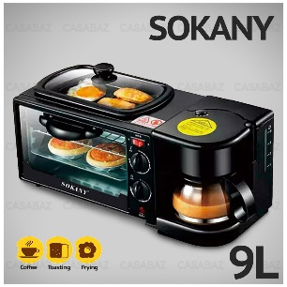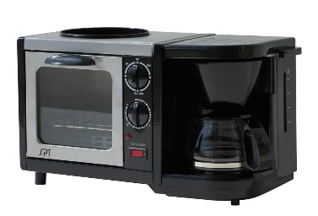

Class:

Microwave Oven

Properties:

Brand

Model

Oven capacity

Behaviours:

Bake()

Grill()

Defrost()

Brand: Samsung

Model: MS-32J5133GM

Oven capacity: 32L

Brand: Panasonic

Model: NN-CD87KSMPQ

Oven capacity: 34L

Brand: Sharp

Model: SHP-R759EBS

Oven capacity: 28L

